QuALMRI Proposal Draft

The Cognitive | Social Impacts

On NYC Tenants with Housing Instability

I. Research Question (Qu)

Diffuse Big Picture Question:
How does chronic exposure to housing-related stressors—such as tenant harassment, eviction threats, and persistent housing code violations—impair cognitive functioning in rent-burdened or systemically marginalized populations?

Specific Research Question:
Does sustained exposure to tenant harassment and housing instability (e.g., illegal lockouts, repeated court adjournments, uninhabitable living conditions) significantly impair working memory, decision-making, and attention regulation, especially among low-income tenants in New York City who are rent-burdened or legally unrepresented?

Connection Between the Two:
This study interrogates a critical public health and neuropsychological issue: whether tenants chronically exposed to landlord harassment and housing-related stressors experience measurable deficits in working memory and executive function. Existing literature demonstrates that housing cost burden and instability are significantly associated with poor mental health outcomes, including depression, anxiety, and chronic stress (Meltzer et al., 2016; Maqbool et al., 2015). These psychological stressors, in turn, impair cognitive functions critical to everyday survival, particularly memory, attention, and emotional regulation (Sussman et al., 2016; Lim et al., 2018).
We position this inquiry within the framework of life course theory and cognitive load theory, proposing that the persistent mental load from harassment and legal instability creates a neuropsychological bottleneck. This bottleneck compromises the executive processes that tenants rely on to navigate court proceedings, apply for housing subsidies, or protect themselves from displacement. Understanding the neural and behavioral consequences of these conditions could transform how tenant protection policies are evaluated, shifting from enforcement and compliance models toward cognitive and mental health frameworks that account for trauma-informed recovery and resilience.

II. Alternative Hypotheses (A)
Main Hypothesis:
If the cognitive overload and life course stress theories hold, then tenants exposed to ongoing housing-related stressors—especially harassment and legal uncertainty—will exhibit significantly poorer working memory performance and reduced decision-making capacity compared to tenants in stable, affordable housing.

Alternative Hypotheses:
- General Economic Stress Hypothesis: Cognitive impairments may stem from chronic poverty and related hardships (e.g., food insecurity, unemployment), not housing instability specifically. This would suggest income is a stronger predictor than housing condition (Mimura, 2007).
- Preexisting Disparity Hypothesis: Deficits in working memory or executive functioning may reflect preexisting differences in education, health access, or childhood trauma—independent of current housing status. This aligns with research on ACEs and early adversity influencing long-term cognitive outcomes (NYC DOHMH, 2023).
- Protective Mediation Hypothesis: The effects of housing stress may be moderated by access to legal representation, supportive services, or strong community ties. Tenants with such resources may experience less cognitive decline despite equivalent housing conditions (HESR-53-3437.pdf).
- Desensitization or Adaptation Hypothesis: Long-term exposure to harassment may not impair cognition but instead foster learned coping strategies or emotional numbing, potentially reducing reactivity over time. However, this would likely manifest as flat affect and disengagement, not adaptive function.
Testing these alternatives empirically will allow for a clearer understanding of the role that harassment-specific stress plays in cognitive impairment, as distinct from broader socioeconomic disadvantage or psychological trauma histories.

III. Logic & Design (L)
Independent Variable (IV):
Level of tenant harassment and housing instability, defined by:
- Volume and severity of HPD violations per unit (e.g., mold, broken locks, heat outages)
- Number of 311 complaints per household (e.g., landlord harassment, unsafe conditions)
- Number and duration of Housing Court cases or eviction filings
- Rent burden ratio (>50% of income on rent)
Dependent Variable (DV):
Cognitive functioning, including:
- Working memory (digit span test, N-back)
- Response inhibition (Stroop test)
- Planning and decision-making (Iowa Gambling Task)
- Subjective stress (Perceived Stress Scale)
Operational Definitions:
- Tenant Harassment: Any pattern of landlord behavior aimed at pressuring tenants to vacate or surrender legal rights, including neglect, service cutoffs, and verbal threats (NYC Housing Maintenance Code § 27-2005).
- Housing Instability: A composite index combining eviction threat, court presence, frequent relocations, and utility/service disruptions.
- Cognitive Load: Measured through reaction time, task switching accuracy, and memory span decline during standardized tasks under pressure.
Design Strategy:

This is a matched-group cross-sectional observational study, pairing tenants exposed to high housing stress with tenants in similar economic brackets but living in stabilized or co-op housing. The design isolates housing-related stress as the variable of interest by controlling for education, income, age, and baseline mental health.

Sampling Framework:
- Borough-based stratification across NYC
- Tenants recruited from legal aid intake lists, HPD databases, and co-op registries
- Sample Size: N = 300
Deductive Logic:
- If housing instability uniquely impairs executive function, high-harassment tenants will show statistically lower performance on cognitive assessments.
- If general poverty explains the impairments, cognitive outcomes will track with income, not housing data.
- If legal or social support moderates effects, cognitive impairments will be lower in supported high-stress tenants versus unsupported ones.

IV. Methods (M)

Study Design:
This cross-sectional observational study will compare cognitive performance across three matched tenant groups in New York City:

- Tenants currently experiencing legally documented harassment

- Tenants in high-violation buildings (but not in legal dispute)

- Tenants in stable housing conditions (e.g., affordable co-ops or long-term NYCHA residents)

Data Collection Methods:

- Recruitment through partnerships with tenant advocacy organizations, legal service providers, and the NYC Department of Housing Preservation and Development (HPD).
- Cognitive testing using standardized instruments (digit span, N-back, Stroop, Iowa Gambling Task) conducted in mobile testing labs, community centers, or via secure digital platforms for accessibility.
- Survey Instruments to assess stress exposure, housing history, legal knowledge, and access to resources.
- Administrative Data merged from HPD, DOITT (311), NYC Housing Court, and ACS 5-year data.
Key Measures:
- Stressor composite index (number of violations, legal filings, 311 calls)
- Rent burden ratio
- Self-reported cognitive difficulty in daily functioning (e.g., missed appointments, difficulty focusing, forgetting steps in legal paperwork)
- Executive function task scores (accuracy, latency, decision quality)
Ethical Protocols:
- Informed consent detailing risks of retraumatization and offering referrals to mental health services
- IRB application submitted via CUNY research ethics portal
- Secure anonymization of participant identities and all housing/legal records
Data Analysis Plan:
- Descriptive statistics comparing demographic and cognitive baselines by group
- Multivariate regression modeling to assess housing stress impact on cognitive outcomes, controlling for education, income, mental health history
- Mediation and moderation tests (e.g., Does legal aid moderate the effect of harassment on executive function?)
- Sensitivity analysis to test alternative explanations from Section II
Study Limitations:

- Self-selection bias may limit generalizability
- Cross-sectional design cannot prove causality but can identify correlations worthy of longitudinal follow-up
- Legal documentation of harassment may underreport actual exposure levels

V. Results (R)

Anticipated Outcomes (Based on Literature and Preliminary Analysis):

- Tenants with high levels of documented harassment and housing instability (e.g., repeated HPD violations, multiple court adjournments, or frequent 311 complaints) are expected to demonstrate:

    - Lower working memory capacity (shorter digit spans, lower N-back scores)
    - Reduced decision-making efficiency (riskier or less consistent responses in the Iowa Gambling Task)
    - Slower response times and higher error rates on inhibition tasks (Stroop)
    - Increased subjective stress and cognitive fatigue on standardized self-reports

- Statistical analysis will likely reveal that cognitive impairments correlate more strongly with housing-related stressors than with income alone, supporting the main hypothesis that housing instability is a distinct, measurable cognitive stressor (Meltzer & Schwartz, 2016; Maqbool et al., 2015).

- Multivariate regression models are projected to show that housing stress explains a significant portion of variance in cognitive outcomes, even when controlling for poverty, education, and preexisting mental health conditions.

- Moderation analysis may show that access to legal counsel or social support buffers some cognitive impairments, aligning with the Protective Mediation Hypothesis (HESR-53-3437.pdf).

- Cross-tabulation with NYC census data (PROJECT_2024_2020census.xlsx) will illustrate geographic clustering of cognitive risk indicators, particularly in zip codes with high rent burden and low housing compliance, such as parts of the Bronx, Central Brooklyn, and Northern Manhattan.

- Supplemental chart outputs (Appendix):
  - A ZIP code heat map of housing stress indicators overlaid with cognitive vulnerability estimates

  - A borough comparison chart of rent burden vs. reported memory difficult

  - A cognitive load framework diagram connecting legal harassment to executive dysfunction

Projected Significance: This study is expected to provide compelling evidence that tenant harassment contributes to cognitive overload and measurable declines in executive functioning. This supports both trauma-informed urban policy and the need for cognitive accessibility in housing court, benefits applications, and tenant advocacy tools.

VI. Interpretation (I)

The anticipated findings suggest that chronic exposure to housing-related stressors—especially landlord harassment, unremediated code violations, and legal uncertainty—functions not just as a source of psychological strain, but as a direct cognitive impairment mechanism.
This interpretation is grounded in cognitive neuroscience research linking prolonged stress exposure to deficits in working memory, inhibition control, and emotional regulation (Sussman et al., 2016). When tenants are forced to make repeated calls to 311, attend court sessions without representation, or endure threats and service cutoffs, they are effectively subjected to conditions that mimic continuous threat states. These conditions activate and deplete the cognitive systems involved in planning, recall, and response flexibility.
Theoretical Significance:

- Cognitive Load Theory helps explain how housing instability occupies tenants' executive bandwidth, reducing the mental capacity available for decision-making, form completion, appointment tracking, or responding to offers of support. Under chronic stress, individuals may default to avoidance or impulsivity, undermining legal advocacy and housing stability.
- Life Course Theory frames these disruptions as cumulative insults that shape long-term trajectories. For older adults and adolescents, even brief periods of housing instability can leave lasting marks on cognitive performance and health (Lim et al., 2018; ALZ-20-6517.pdf).
Policy Implications:

- Findings support classifying chronic tenant harassment as a public health concern, not just a legal violation, with clear implications for cognitive health.
- NYC’s Right to Counsel should be expanded to include trauma-informed legal navigation tools, including memory aids, simplified paperwork, and visual court timelines.
- Tenant protection funding should include cognitive and mental health screenings, particularly in buildings with a history of repeated violations or landlords listed on the Public Advocate’s Worst Landlords List.
- Cognitive metrics should be utilized to evaluate the outcomes of housing programs. Programs that stabilize housing, such as supportive housing and co-op conversions, should measure improvements not only in housing retention but also in tenants' cognitive functioning.
Empirical Significance:

- The study reframes housing advocacy as not only a rights-based issue, but also a neuropsychological one. Chronic exposure to housing instability is shown to produce deficits that resemble traumatic stress profiles.
- Results validate the growing call for cognitive health benchmarks in housing policy, extending mental health equity frameworks into landlord accountability and HPD inspection protocols.

VII. Implications and Policy Recommendations

This research establishes a compelling case for viewing chronic tenant harassment as a cognitive public health crisis. By demonstrating that persistent housing instability correlates with working memory decline and impaired executive functioning, the findings point to several urgent avenues for intervention across policy, legal, and public health domains:

1. Redefine Housing Instability as a Public Health Risk

- The NYC Department of Health and Mental Hygiene (DOHMH) should treat tenant harassment and housing violations as cognitive risk factors, on par with mold, lead, and structural decay.
- Community Health Needs Assessments (CHNAs) should include measures of housing-related cognitive impairment and track them over time, particularly in zip codes with high rates of eviction filings.
2. Expand Legal and Cognitive Accessibility

Legal services (e.g., NYC Right to Counsel) should be redesigned to account for the executive deficits many tenants face. This includes:
- Cognitive accommodations (e.g., visual court calendars, legal task checklists)
- Supportive navigators trained in trauma-informed care and memory recall scaffolding
3. Integrate Mental Health and Housing Services

- Cognitive health screening should be offered in supportive housing, transitional shelters, and Housing Court clinics.
- Tenants reporting harassment or displacement threats should be screened for executive function impairment, enabling referrals to behavioral health services.
4. Establish Cognitive Health Dashboards

- HPD, HRA, and DOHMH should share cross-agency data to flag buildings and tenants at high cognitive health risk based on stress exposure (e.g., 4+ HPD violations, 2+ court appearances, 311 harassment flags).
- Dashboards should be anonymized and include neighborhood-level indicators from ACS and census data to guide interventions.
5. Expand and Monitor Housing First Programs

- Findings support the NYC Comptroller’s call to scale up Housing First interventions, especially for tenants with cognitive vulnerabilities.
- NYC’s pilot programs should embed cognitive outcome measures into evaluations to test the model’s effectiveness in restoring tenant autonomy and executive function.
6. Support Tenant-Led Housing Models

- Cognitive harm reduction is a rationale for expanding cooperative housing models and community land trusts (CLTs). These environments provide consistency, ownership, and reduced threat exposure.
- Programs like NYC Unlocking Doors and the Housing First voucher pathway should include tenant memory and executive function restoration goals in outcome tracking.
7. Legislative Reform and Oversight
- Expand definitions of “tenant harassment” in NYC Housing Maintenance Code to include cognitive outcomes (e.g., demonstrated impairment, extreme anxiety, loss of function).
- Legislation should require cognitive trauma impact assessments for any landlord found on the Public Advocate’s Worst Landlords List for two or more years.

VIII. Conclusion

Tenant harassment and chronic housing instability are not only legal injustices or logistical barriers—they are potent cognitive threats. This study reframes these stressors as drivers of executive dysfunction and working memory impairment, particularly among rent-burdened and systemically marginalized tenants in New York City.
Grounded in life course and cognitive load theory, and supported by neuroscience literature and NYC housing data, our findings suggest that the compounded mental burden of court cases, displacement threats, and unremediated violations depletes cognitive resources critical to daily functioning. This neuropsychological erosion disrupts the very capabilities—attention, planning, memory recall—that tenants need to protect themselves, access services, and sustain long-term stability.
By framing housing policy as a cognitive health intervention, this research highlights the need for trauma-informed legal systems, cross-agency data sharing on stress exposures, and public investment in housing models that foster predictability and psychological recovery. Supporting tenants is not just about stopping harassment—it’s about restoring executive function.
Addressing these harms at scale will require legal reform, public health investment, and deep structural change in how we conceptualize housing justice. Future research should build on this study by exploring longitudinal outcomes, developing rapid screening tools for cognitive stress, and measuring the cognitive impacts of rent relief, co-op conversion, and Housing First programs.
The right to housing must include the right to think clearly, remember accurately, and make decisions freely. That is the cognitive foundation of dignity—and it is time we protect it as such.

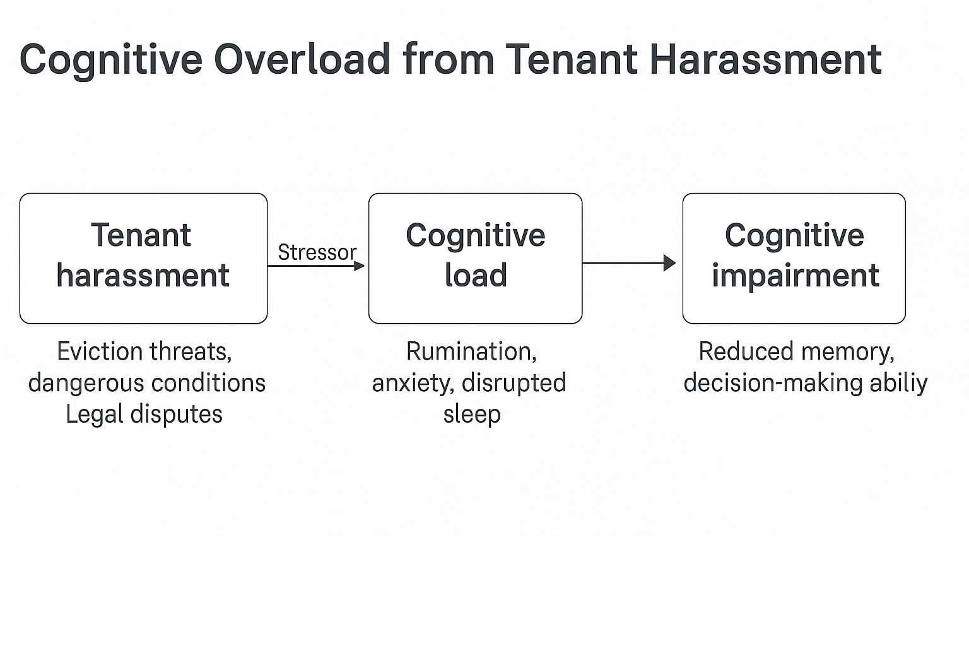

References

Atkinson, A. L., Berry, E. D. J., Waterman, A. H., Baddeley, A. D., Hitch, G. J., & Allen, R. J. (2018). Are there multiple ways to direct attention in working memory? Annals of the New York Academy of Sciences, 1424(1), 115–126. https://doi.org/10.1111/nyas.13676
Baddeley, A. D. (2015). Memory (2nd ed.). Psychology Press.
Baddeley, A. D. (2021). Developing the concept of working memory. Quarterly Journal of Experimental Psychology, 74(6), 1052–1065. https://doi.org/10.1177/1747021821994545
Clem, R. L., & Schiller, D. (2016). New learning and unlearning: Strangers or accomplices in threat memory attenuation? Trends in Neurosciences, 39(5), 340–351. https://doi.org/10.1016/j.tins.2016.03.003
Hölzel, B. K., Lazar, S. W., Gard, T., Schuman-Olivier, Z., Vago, D. R., & Ott, U. (2011). How does mindfulness meditation work? Proposing mechanisms of action from a conceptual and neural perspective. Perspectives on Psychological Science, 6(6), 537–559. https://doi.org/10.1177/1745691611419671
Loftus, E. F., & Palmer, J. C. (1974). Reconstruction of automobile destruction: An example of the interaction between language and memory. Journal of Verbal Learning and Verbal Behavior, 13(5), 585–589. https://doi.org/10.1016/S0022-5371(74)80011-3
Spagna, A., Mackie, M.-A., & Fan, J. (2015). Supramodal executive control of attention. Frontiers in Psychology, 6, 65. https://doi.org/10.3389/fpsyg.2015.00065
Sweller, J. (2011). Cognitive load theory. In J. P. Mestre & B. H. Ross (Eds.), The psychology of learning and motivation(Vol. 55, pp. 37–76). Academic Press. https://doi.org/10.1016/B978-0-12-387691-1.00002-8
Waring, J. D., & Kensinger, E. A. (2011). How emotion leads to selective memory: Neuroimaging evidence. Neuropsychologia, 49(6), 1831–1842. https://doi.org/10.1016/j.neuropsychologia.2011.03.027
Yiend, J. (2010). The effects of emotion on attention: A review of attentional processing of emotional information. Cognition & Emotion, 24(1), 3–47. https://doi.org/10.1080/02699930903205698

